Name:  Class: | ____________________________________  ________________ |  | Date:_________
 | Year 7 Mathematics  Test 1, Term 3 2020  Topic – Statistics |  | / 30  %
Total Time: | 30 min
Weighting: | 10 %
Equipment: | Page of notes and a calculator

Question 1 4 marks
Draw a line to link the source of data to the Primary Data or Secondary Data accordingly.

Source of Primary Data | Source of Secondary Data

Observations | Websites | Experiments | Government publications

Question 2 4 marks
Calculate the mean, median, mode and range of the data:
3, 3, 4, 4, 4, 5, 6
Mean | Median | Mode | Range

Question 3 8 marks
Use a stem and leaf plot to represent the following data. Also find the mean, median, mode and range. The weekly house rents ($):
348 , 329, 349 , 351, 353 , 350 , 340 , 349 , 350 , 348 , 349 , 357 , 361

Mean | Median | Mode | Range
Question 4 11 marks
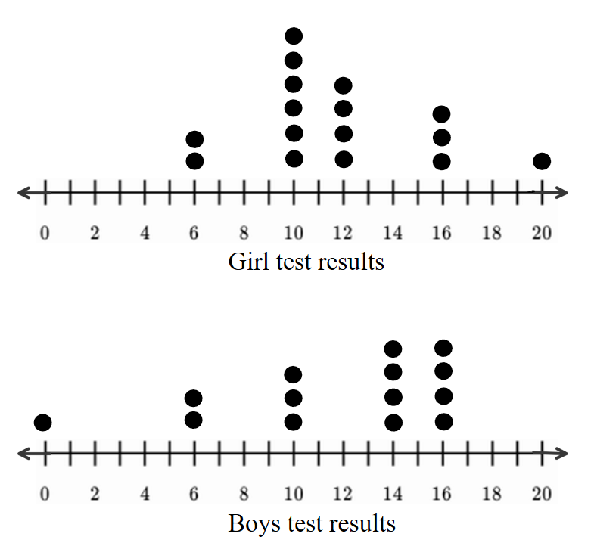
Use the above dot plot to determine the mean, median, mode and range for girls and boys test results.
Girls test results | Boys test results
Mean : | Mean :
Median : | Median :
Mode : | Mode :
Range : | Range :
Compare the mean, median and mode of their test results, which group has a better result? Why? Justify your answer.

Question 5 3 marks
Five scores have an average of 8.2. Four of those scores are 10, 9, 8 and 7. What is the fifth score?

End of Test

